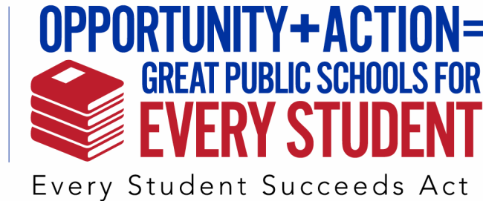

Sample School Board Resolution

WHEREAS, our nation’s future well-being relies on a high-quality public education system that prepares all students for college, careers, democracy, and lifelong learning; and

WHEREAS, our nation’s school systems have been making too many critical decisions without benefit of the voices and expertise of the educators who know students’ names in our schools; and

WHEREAS, our nation’s public school systems have been spending growing amounts of time, money, and energy on high-stakes standardized testing, in which student test scores are used to make major decisions affecting individual students, educators, and school; and

WHEREAS, the overreliance on high-stakes and standardized testing in state accountability systems is undermining educational quality and opportunity in the U.S. public schools by hampering educators’ efforts to focus on creativity, problem-solving, collaboration, communication, critical thinking, and deep subject matter knowledge that will allow students to thrive in a democracy and an increasingly global society and economy; and

WHEREAS, a child’s chances for success should not depend on living in the right zip code; and

WHEREAS, the President of the United States signed the Every Student Succeeds Act on December 10, 2015 based on educators’ call to end No Child Left Behind’s misguided federal mandates; and

THEREFORE, let it be resolved that the [your School District Governing Board name] supports the collaborative development and implementation of a plan with the [your Local Affiliate name], parents, students, and community members to ensure the opportunities for a well-rounded education presented by
the Every Student Succeeds Act realized by including all stakeholders in decision-making;

THEREFORE, let it be resolved that [your School Board name] calls on the governor, state legislature, and the state education boards and administrators to reexamine public school accountability and finance systems in this state to ensure that accountability for district, school and student success are based on multiple forms of evidence that feature indicators of school and student supports and success; and that those indicators are used to drive resources and a system of improvement strategies to schools (collaboratively developed by all stakeholders) so that all students receive the opportunities and supports they deserve.

